**AWS Cloud Front**

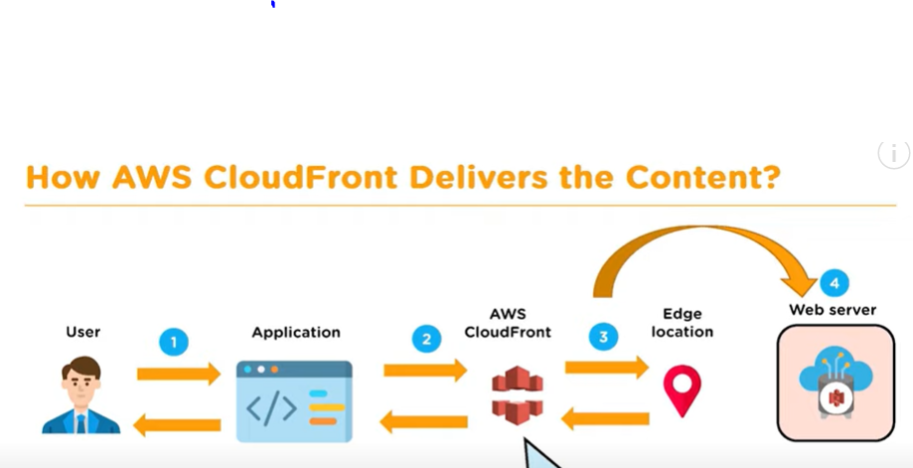

AWS Cloud Front

===============

It is global distributed network offered by AWS which securely delivery the content to the end users

with high transfer speed with low latency.

Content cache stored in nearest edge location. AWS communicate the nearest Edge location to access the content.

Demo: Architecture

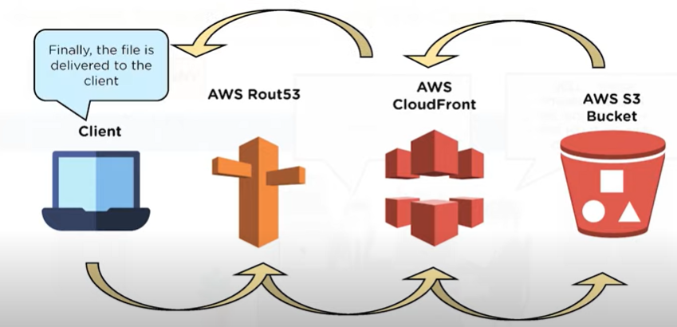

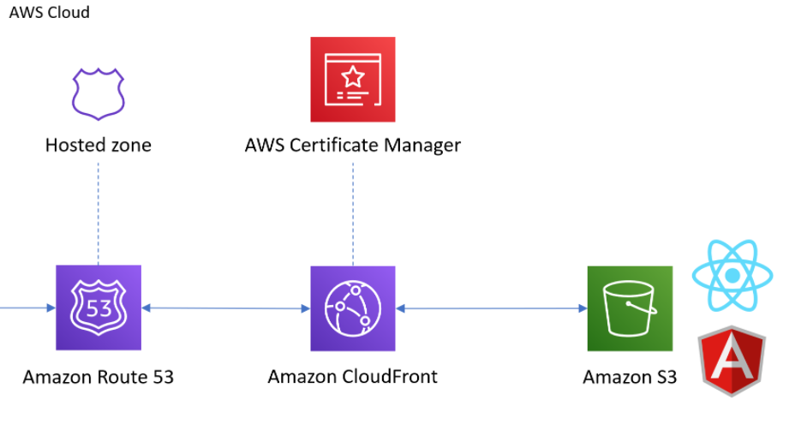

Pre-request

==========

1. Create two S3 bucket one for static website and another one to redirect https.
2. Need domain and registered with help of R53.
3. Configure SSL for domain using ACM
4. Configure distribution using CloudFront.

Create domain and register in R53

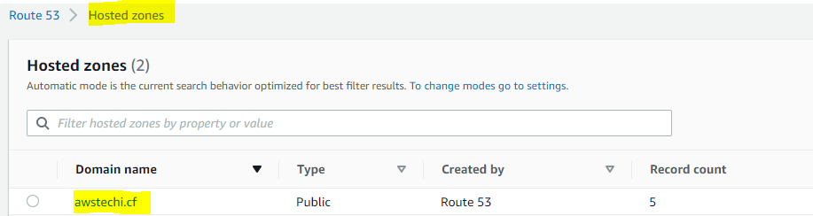

Create SSL certificate for two domain using **ACM** and create **CNAME** for both.

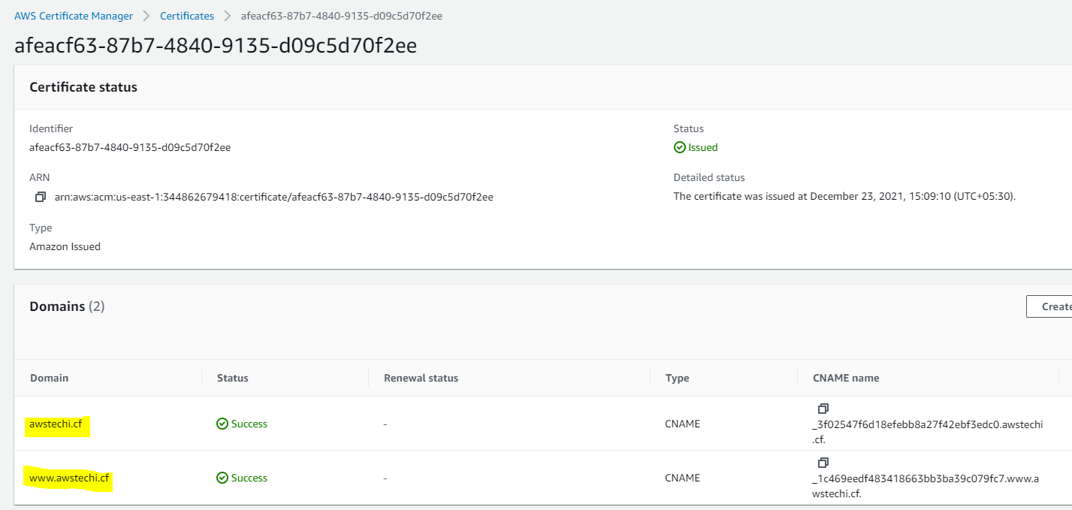

CNAME is added in domain.

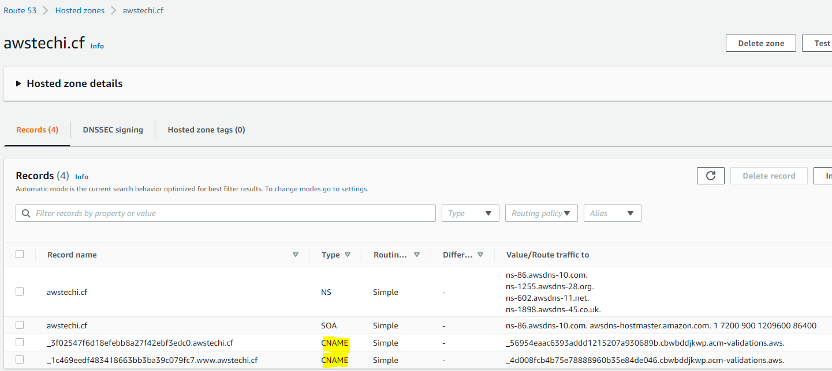

Create two buckets.

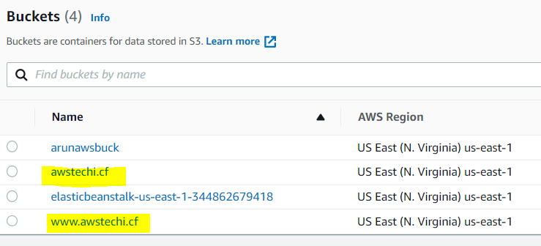

Set up public access for [www.awstechi.cf](http://www.awstechi.cf) bucket and configure static website



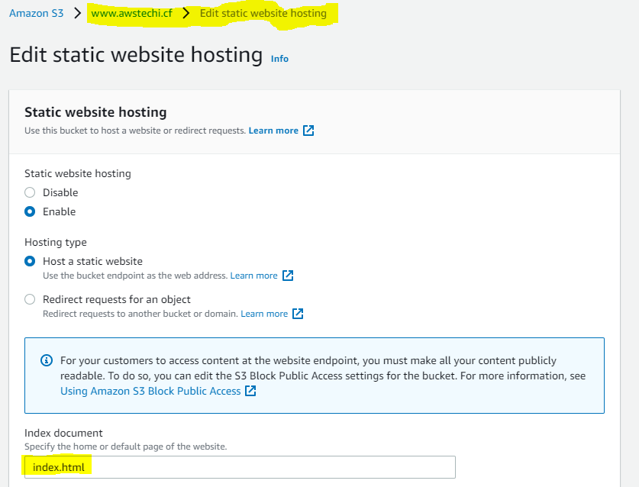

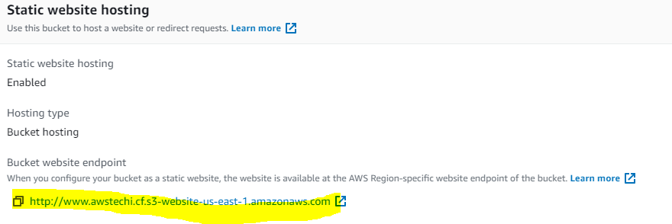

Upload some objects:

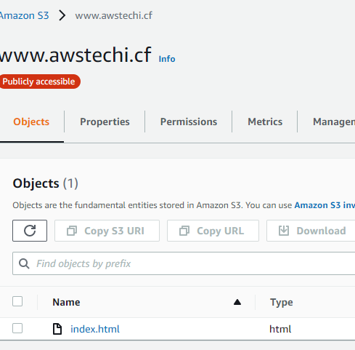

Copy the object URL in browser and check the traffic.

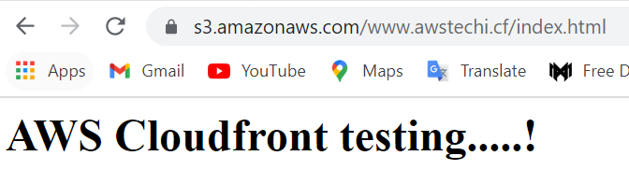

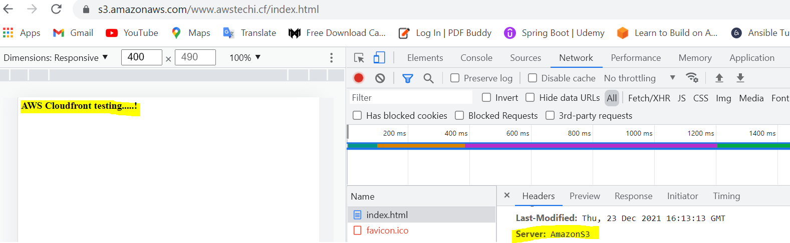

Create another bucket for https redirection.

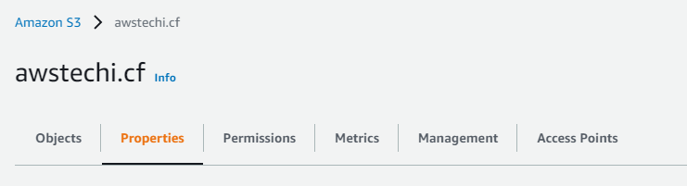

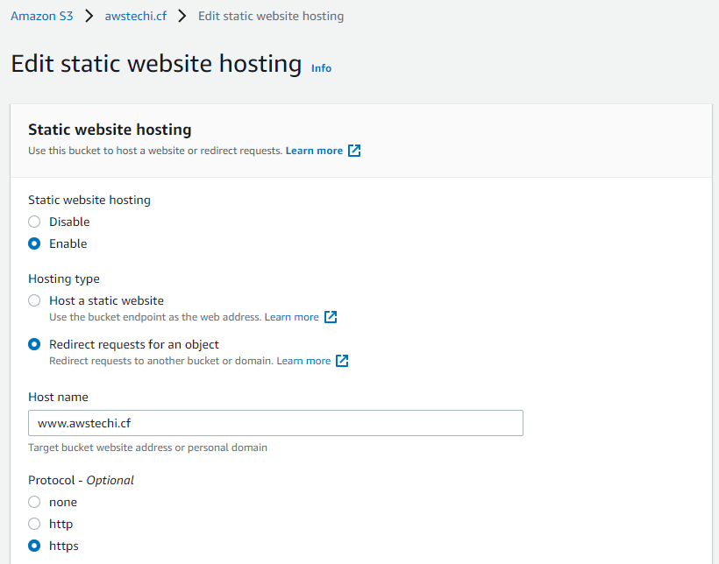

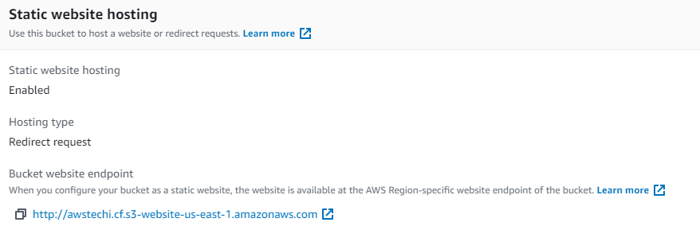

Create distribution CloudFront

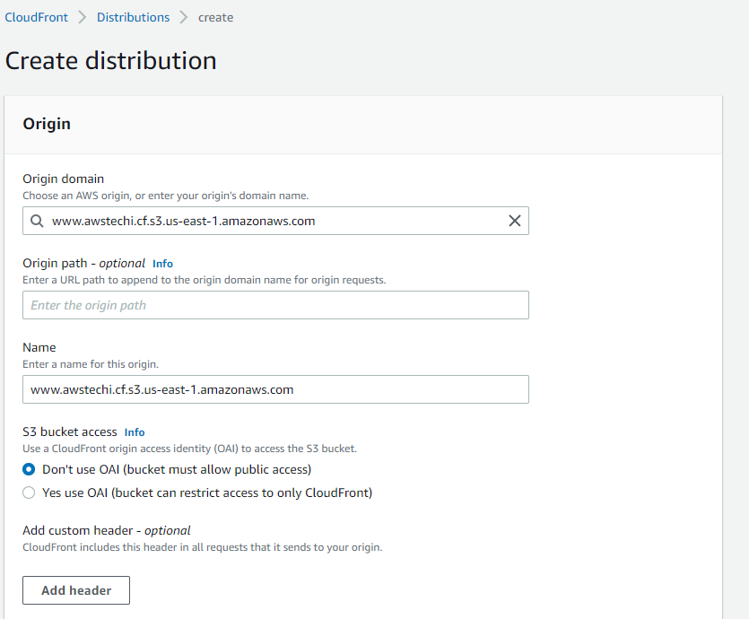

Enter CNAME and add SSL certificate

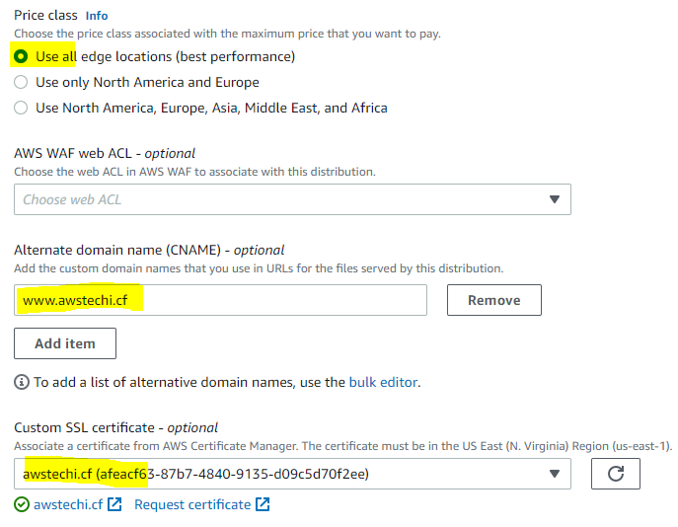

Create another Distribution for 2nd bucket

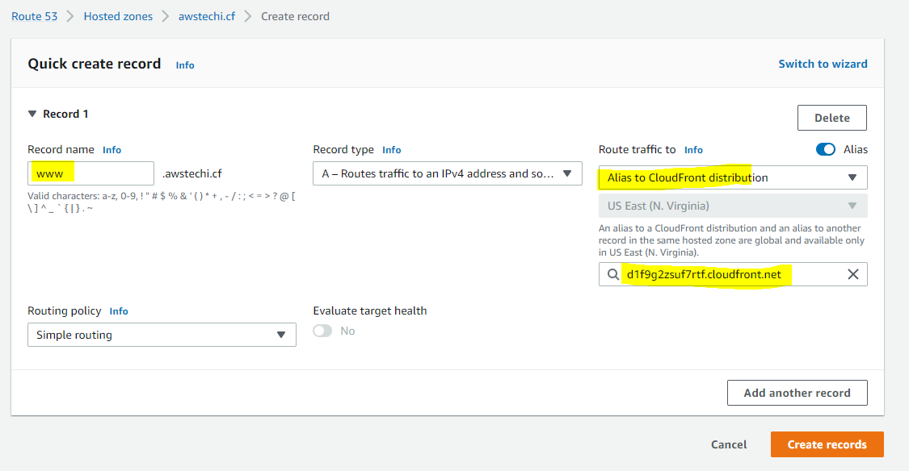

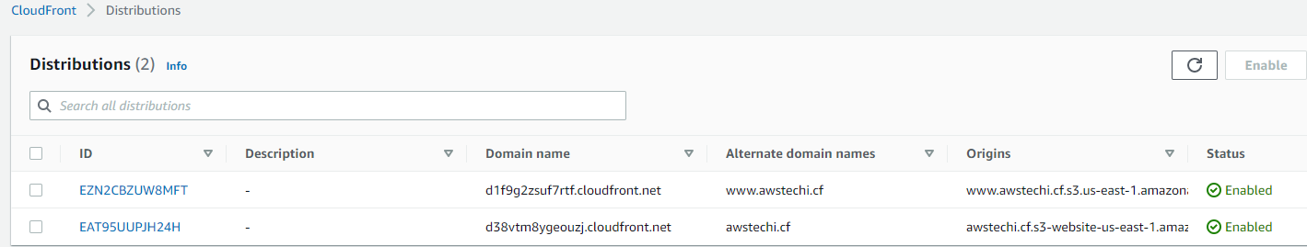

Create A records for two domains in R53

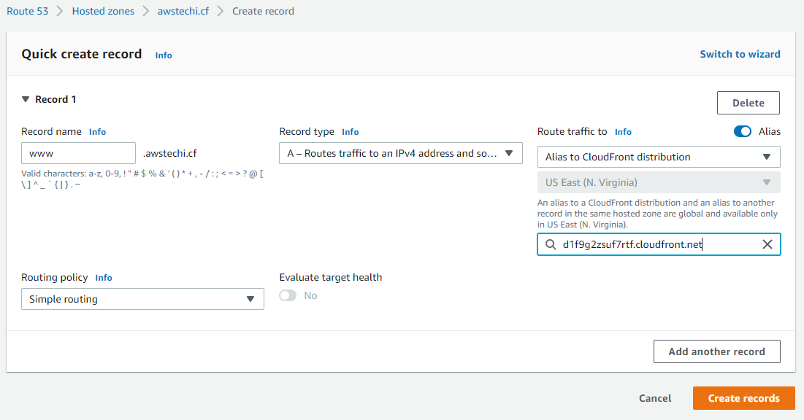

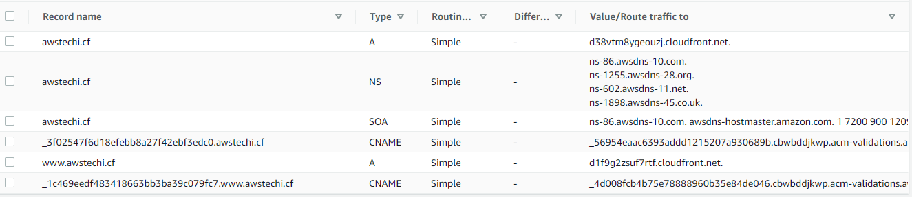

Copy the domain name for [www.awstechi.cf](http://www.awstechi.cf) in browser and check the traffic.

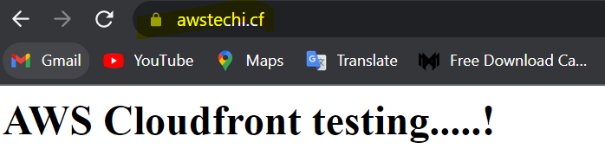

Now the content displaying with CloudFront traffic.

